ACT Endurance Riders Association
National Capital ‘Brookvale’ Endurance Ride Weekend
26 & 27 September 2015

RIDE REVIEW

On Saturday 26 and Sunday 27 September, the ACT Endurance Riders Association (ACTERA) held a two day training and social ride carnival at our traditional ridebase of ‘Brookvale’ located in the foothills of the Brindabella Mountains.

The Brookvale ridebase was picture perfect and we enjoyed two days of excellent riding weather. The tracks were also in great condition – many of the forestry and national parks tracks having been graded recently – making it softer underfoot for the horses (many of them barefoot!). The smiling faces around camp over the weekend indicated that everyone was having a good time!

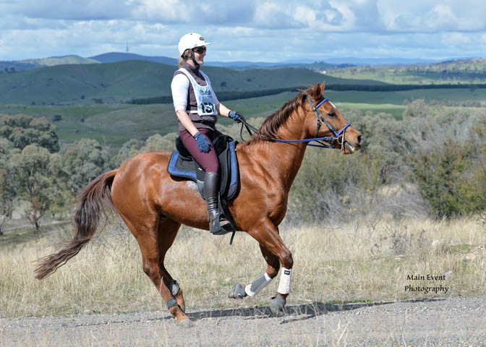
Louisa Briggs and Cheeky cruising around the scenic Brookvale course.
(Main Event Photography)

There were 88 entries in total for all ride distances over the weekend – 10/20 and 30km on Saturday and 10/20/30/40 and a 50km elevator on Sunday. There was a good mix of experienced horses and riders, new comers, and new or young horses over the weekend learning the ropes.

Overall, the rides resulted in excellent completion rates - with only a couple of vet outs over the whole weekend. Our 10km ride (in fact 13kms after having to change the course) proved a treat for those who are new to the sport of Endurance. It was great to see some of our newest ACTERA members including Louisa Briggs, Tammie Spackman and Julie Hooper riding the 22km ride and completed with smiles on their faces.

The 40km ride was challenging, with an 8km climb to the top of Blue Range but everyone seemed to enjoy the views and a breather at the top before riding through the Brindabella National Park back to the ridebase. Either everyone was in cruise mode or it got a little too warm on Sunday afternoon, as only two of our seven 50km elevator contenders chose to go out again on the second leg. Congratulations to Courtney Chapman riding Kars Springs Ice Lite and Erica Allan riding Kaminya who deserve a special mention as the two riders who completed the 53km ride together in 5:40hrs. Well done!

Thank you to our special sponsors, ViziHorse, ZemZem Arabians and Kristen Proudfoot and Searle Johnson from Bendora Arabians for their generous support for the Brookvale ride.

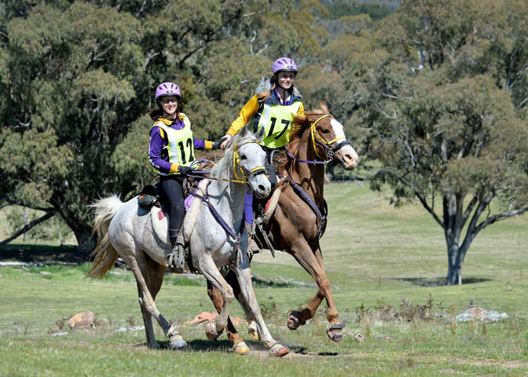
Adeline, Talea & their Blake’s Heaven horses enjoying the ride! (Main Event Photography)

ACTERA would like to thank our Chief Steward Belinda Hopley, Ride Secretary Gertraud Norton, our wonderful vets Steve Roberts and Simon Bain and our TPRS and fabulous volunteers who helped over the whole weekend. We couldn’t have done it without you!!

Thanks also go to Burra Berkshires Catering for providing delicious food over the weekend and Peter Orr from Main Event Photography for coming to Brookvale. Peter’s photos are available on his website: http://www.maineventphotography.com.au/photo_categories.php?catid=251

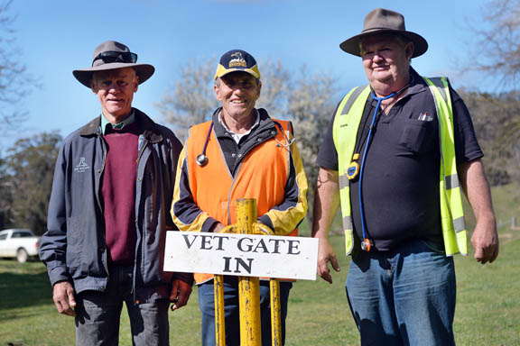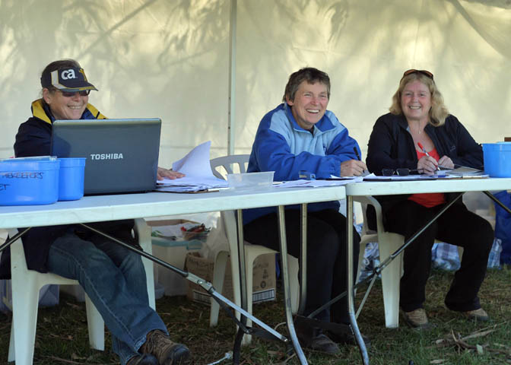
Our fantastic vets, TPRs and office people – thankyou! (Main Event Photography)

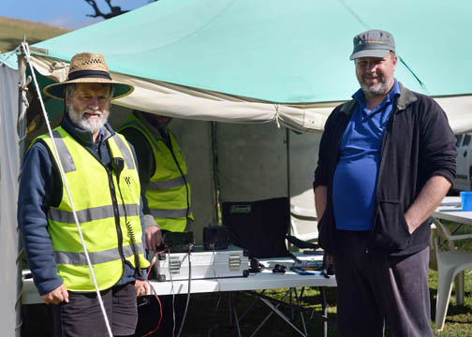
Wonderful WICEN manning the radios! (Main Event Photography)

ACTERA: www.actera.org.au – or  facebook us at ACT Endurance Riders Association.

